EXPT NO:5 | DEVELOP INTERACTIVE DASHBOARDS FOR DYNAMIC DATA EXPLORATION USING TABLEAU AND POWERBI
DATE: 24.07.2026

PRE-LAB QUESTIONS (PROVIDE BRIEF ANSWERS TO THE FOLLOWING QUESTIONS) :

- What is dynamic data exploration in BI tools, and why is it important?
Dynamic data exploration allows users to interact with data in real time using filters, slicers, and different views. It helps identify trends and patterns more easily, making analysis faster. This supports better understanding of the data and improves decision-making.

- What are slicers and filters, and how do they enhance dashboard interactivity?
Slicers and filters allow users to display only the required data based on their selection. They make dashboards more interactive by focusing on specific information. This simplifies data analysis and provides a better user experience.

- How do Tableau and Power BI support drill-down and drill-through features?
Tableau and Power BI support drill-down and drill-through to explore data in greater detail. Users can move from summary information to detailed records with just a few clicks. These features help in gaining deeper insights and understanding trends effectively.

- What is the role of parameters in creating interactive dashboards?
Parameters allow users to change values that control charts, calculations, and visualisations dynamically. They make dashboards more flexible by providing customised views of the data. This improves user interaction and enhances the overall analysis process.

- Name some advanced interactivity features in Tableau and Power BI.
Tableau and Power BI provide advanced features such as drill-down, drill-through, tooltips, bookmarks, slicers, and parameters. These features make dashboards more interactive and engaging for users. They also improve data exploration and support better business insights.

IN-LAB EXERCISE:
OBJECTIVE:
To design and develop interactive dashboards in Tableau and Power BI for dynamic data exploration, enabling users to analyze, filter, and drill down into data for deeper insights.
PROCEDURE:
- Data Collection:
    - Import datasets from sources such as Excel, CSV, SQL Server, or online APIs.
    - Dataset: Retail Sales Dataset with fields such as Order Date, Region, Product Category, Sales, Profit, Quantity.
- Data Preparation and Transformation:
    - Ensure proper date formats for time-based analysis. o Handle missing or incorrect values.
    - Create calculated fields (e.g., Profit Margin %, Sales Growth %, Year-to-Date Sales).
- Data Aggregation and Hierarchies:
    - Create hierarchies (e.g., Year → Quarter → Month → Day).
    - Aggregate data by region, product category, or customer segment.
- Designing Interactive Elements:
    - Filters & Slicers: Allow filtering by product category, date range, or region. o Parameters: Let users switch between KPIs (e.g., Sales vs. Profit). o Drill-down: Enable users to explore data from summary to detail.
    - Tooltips: Add contextual details when hovering over data points.
- Dashboard Development:
    - Tableau: Use interactive filters, parameter controls, and highlight actions.
    - Power BI: Use slicers, bookmarks, and drill-through pages.
    - Add KPI cards for key metrics like Total Sales, Total Profit, Top Selling Product. o Use maps for regional sales analysis, line charts for trends, and bar charts for category comparisons.
- Testing Interactivity:
    - Ensure slicers and filters update all relevant visuals dynamically.
    - Test drill-down and drill-through functionality for accuracy.
- Publishing and Sharing:
    - Tableau: Publish on Tableau Public or Tableau Server.
    - Power BI: Publish to Power BI Service and share via workspace access or public link.
Experiment Dataset:
Retail Sales Dataset
Fields Used:
  - Order Date – Date of the order
  - Region – Sales region
  - Product Category – Category of product sold
  - Sales – Sales revenue
  - Profit – Net profit from the order
  - Quantity – Units sold

POWER BI DASHBOARD :
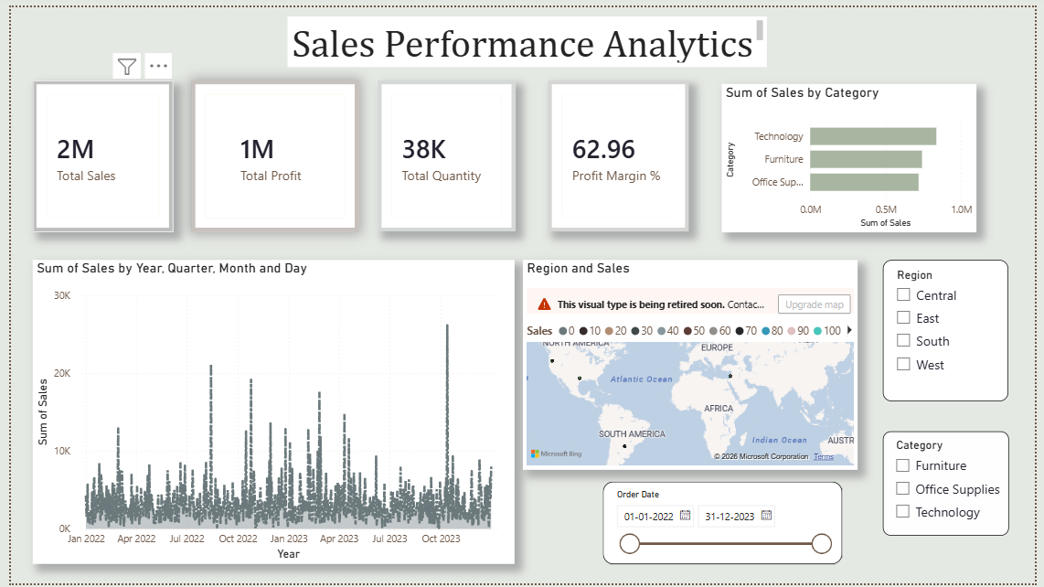
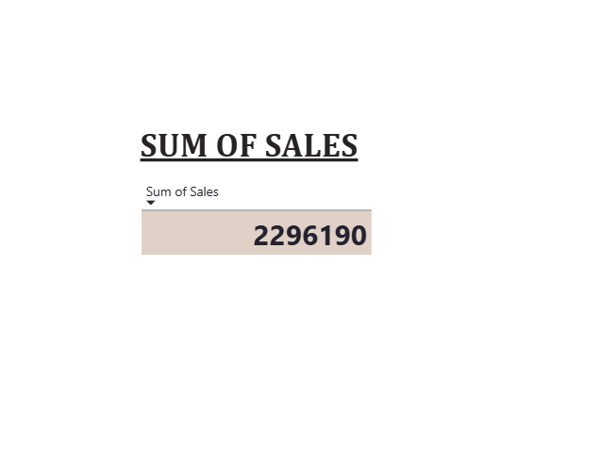
TABLEAU DASHBOARD :

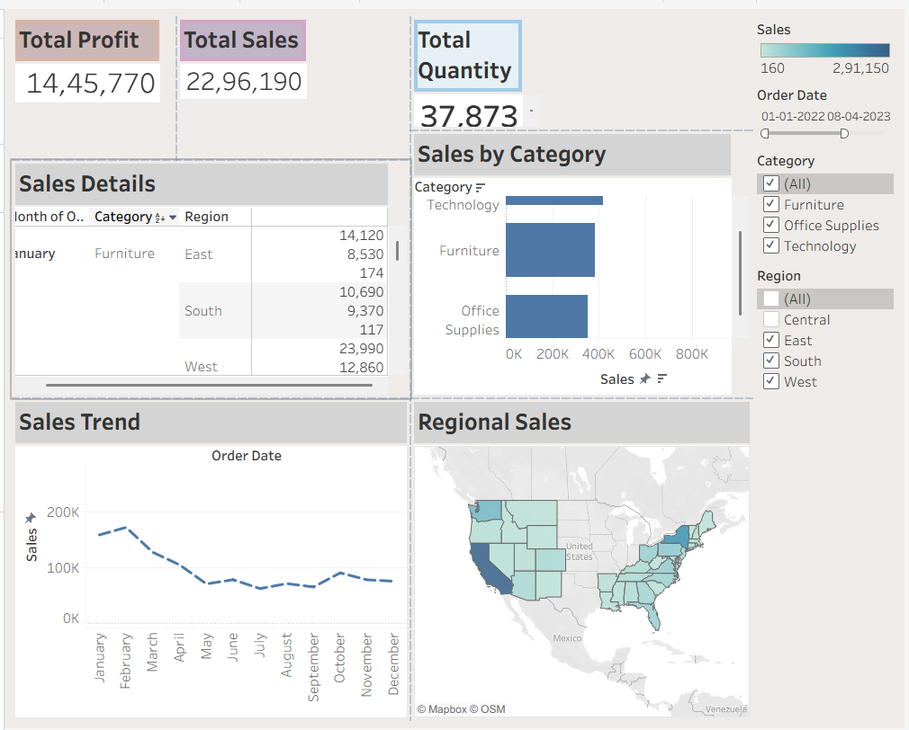

POST-LAB QUESTIONS (PROVIDE BRIEF ANSWERS TO THE FOLLOWING QUESTIONS) :
- How did interactivity improve the analysis experience in your dashboard?
Interactivity made the dashboard easier to explore by allowing users to view data from different perspectives. It helped identify trends quickly and made the analysis more engaging. This improved the overall decision-making process.

- Which interactive feature (filters, drill-down, parameters, etc.) was most useful and why?
Filters were the most useful feature because they allowed quick access to specific data without changing the dashboard. They simplified analysis and made it easier to compare different values. This saved time and improved efficiency.

- What challenges did you face while implementing drill-down or dynamic filters?
One challenge was setting up the correct relationships between data fields. Another was ensuring the visuals updated accurately after applying filters. Careful configuration helped resolve these issues.

- How do tooltips contribute to better dashboard storytelling?
Tooltips provide additional information when users hover over a visual without cluttering the dashboard. They help explain data points more clearly and improve understanding. This makes the dashboard more informative and interactive.

5. What additional features would you add to make the dashboard more insightful?
I would add KPI cards, trend forecasting, and interactive bookmarks to enhance the dashboard. These features would provide deeper insights and improve navigation. They would also make the dashboard more useful for decision-making.

RESULT:

The retail sales dataset was successfully transformed, aggregated, and visualized into interactive dashboards in Tableau and Power BI. Filters, slicers, drill-downs, and parameters enabled dynamic exploration of sales and profit trends by region, product category, and time period. The resulting dashboards allowed for quick insights and deeper analysis, enhancing decision-making capabilities.

ASSESSMENT

Description |  | Max Marks | Marks Awarded
Pre Lab Exercise |  | 5
In Lab Exercise |  | 10
Post Lab Exercise |  | 5
Viva |  | 10
 | Total | 30
 | Faculty Signature

